OBJECT ORIENTED PROGRAMMING
LAB ASSIGNMENT – 1
(Topics – Basic of C++,Classes and Objects)
Q1. Write a program (WAP) to display "Hello World" on console display. WAP to implement the following control characters: ‘\n’ is for new line, or you can use endl – cout<<endl<<“message”; ‘\t’ is for tab ; ‘\a’ is an alarm sound; ‘\r’ is carriage return to go to the beginning of the current line?

Ans.1.
#include<iostream>
using namespace std;
int main()
{
cout<<"\nHello World";
cout<<"\n this is a new line";
cout << endl << "This is another new line.";
cout<<"\t this a tab";
cout<<"\a this is a alaram sound";
cout<<"\r is carriage return to go to the begning of the current line";
return 0;
}
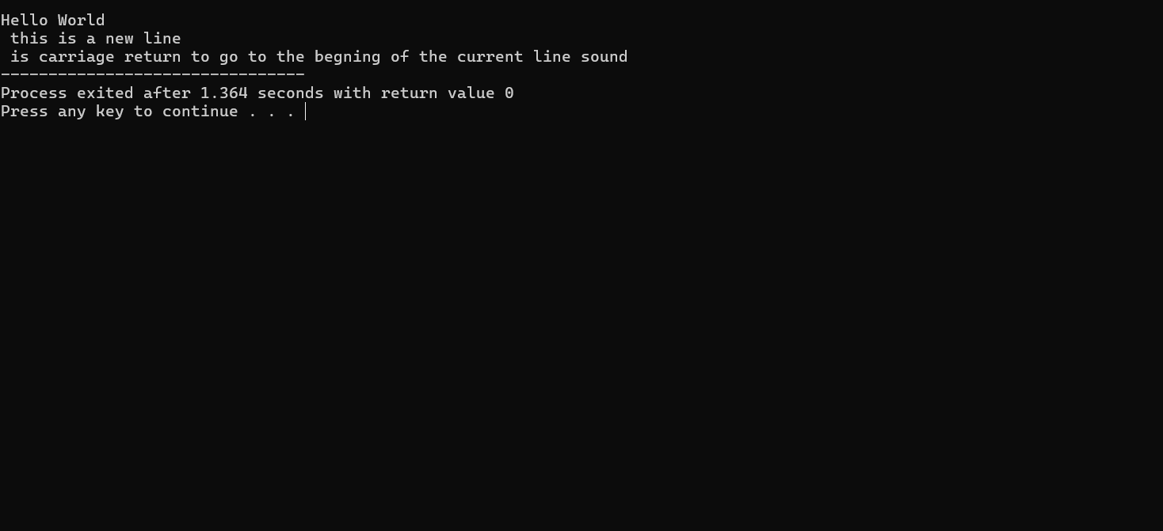

Q2. Write a C++ program that will ask for a temperature in Celsius and display it in degree Fahrenheit.[F=9C/5+32] ?

Ans 2.
#include<iostream>
using namespace std;
int main()
{
float C,F;
cout<<"Enter temperature in Celsius";
cin>>C;
F=(9*C)/5+32;
cout<<"Temperature in Fahrenheit="<<F;
return 0;
}
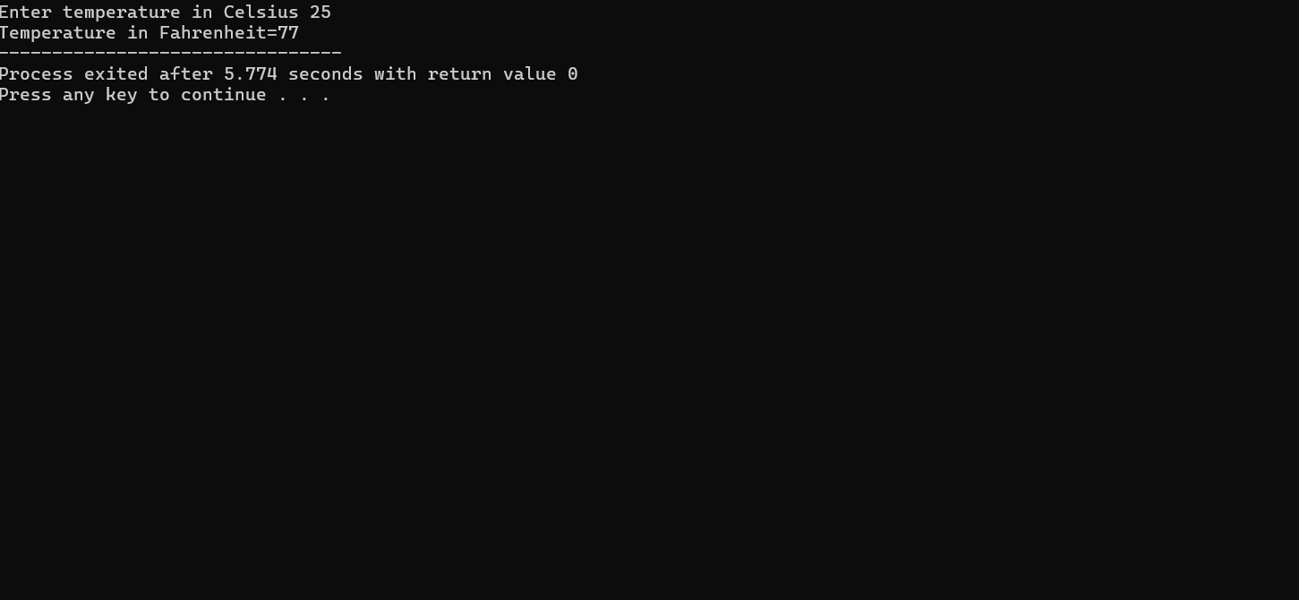
Q3. WAP to demonstrate for, while, do-while (with all possible variations), like for loop can be demonstrated without giving initialization in for construct or without giving increment in for construct. Sample: for (int i=0; i<10; i++) i=0 for (; i<10; i++) i=0 for (; i<10;) i++ ?
Ans 3.
#include <iostream>
using namespace std;
int main()
{
int i;
for(i=0; i<10; i++)
cout << i << " ";
cout << endl;
i=0;
for(; i<10; i++)
cout << i << " ";
cout << endl;
i=0;
for(; i<10;)
{
cout << i << " ";
i++;
}

cout << endl;
i=0;
while(i<10)
{
cout << i << " ";
i++;
}

cout << endl;
i=0;
do
{
cout << i << " ";
i++;
}
while(i<10);

return 0;
}
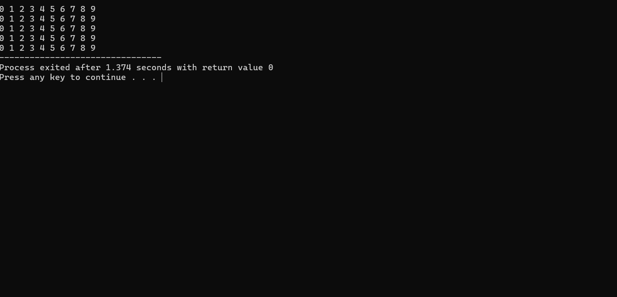

Q4. Create a structure in C++ containing the details of Students as details below and a
main function to execute the structure.
Data Members(properties):
Name
Roll No
Degree
Hostel
CurrentCGPA
Member Function(behavior):
addDetails();
updateDetails();
updateCGPA();
updateHostel();
displaydetails();
Ans.4.
#include <iostream>
using namespace std;

struct Student
{
string Name;
int RollNo;
string Degree;
string Hostel;
float CurrentCGPA;

void addDetails()
{
cout << "Enter Name: ";
cin >> Name;

cout << "Enter Roll No: ";
cin >> RollNo;

cout << "Enter Degree: ";
cin >> Degree;

cout << "Enter Hostel: ";
cin >> Hostel;

cout << "Enter Current CGPA: ";
cin >> CurrentCGPA;
}

void updateDetails()
{
cout << "\nEnter New Name: ";
cin >> Name;

cout << "Enter New Degree: ";
cin >> Degree;
}

void updateCGPA()
{
cout << "Enter New CGPA: ";
cin >> CurrentCGPA;
}

void updateHostel()
{
cout << "Enter New Hostel: ";
cin >> Hostel;
}

void displaydetails()
{
cout << "\n--- Student Details ---" << endl;
cout << "Name: " << Name << endl;
cout << "Roll No: " << RollNo << endl;
cout << "Degree: " << Degree << endl;
cout << "Hostel: " << Hostel << endl;
cout << "Current CGPA: " << CurrentCGPA << endl;
}
};

int main()
{
Student s;

s.addDetails();

cout << "\nOriginal Details:";
s.displaydetails();

s.updateCGPA();
s.updateHostel();

cout << "\nUpdated Details:";
s.displaydetails();

return 0;
}
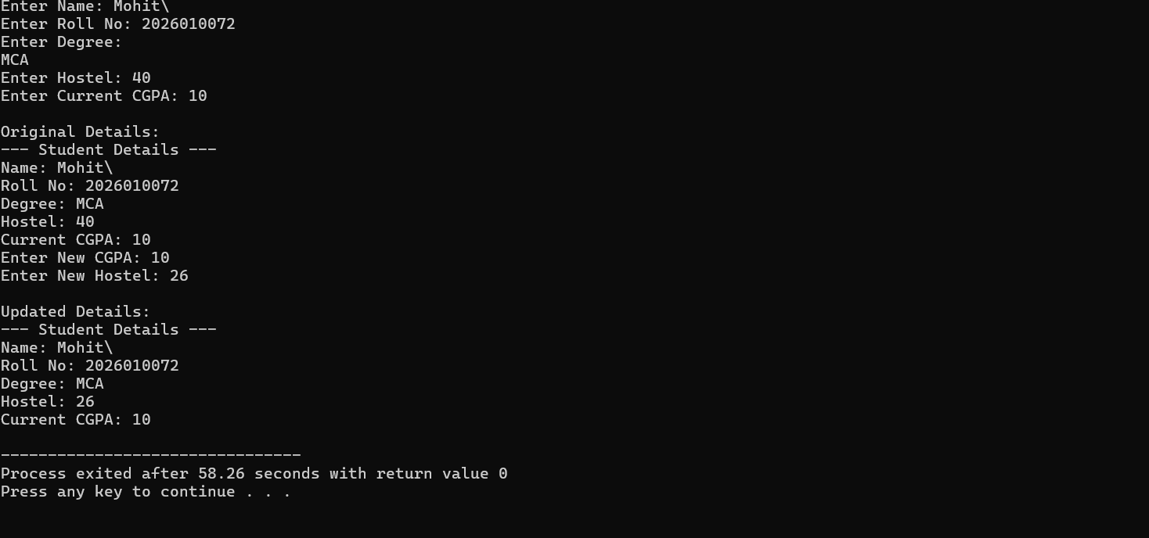
Q5. Differentiate between private and public access/scope. Perform the question no. 4
with class instead of structure with having the data members private and some
member functions in private scope and some in public scope.
Ans 5.

#include <iostream>
using namespace std;

class Student
{
private:
string name;
int rollNo;
string degree;
string hostel;
float currentCGPA;

// Private member function
void showPrivateMessage()
{
cout << "Private function called." << endl;
}

public:
// Public member function
void addDetails()
{
cout << "Enter Name: ";
cin >> name;

cout << "Enter Roll No: ";
cin >> rollNo;

cout << "Enter Degree: ";
cin >> degree;

cout << "Enter Hostel: ";
cin >> hostel;

cout << "Enter Current CGPA: ";
cin >> currentCGPA;

showPrivateMessage();
}

// Public member function
void updateDetails()
{
cout << "\nEnter New CGPA: ";
cin >> currentCGPA;
}

// Public member function
void displayDetails()
{
cout << "\n--- Student Details ---" << endl;
cout << "Name: " << name << endl;
cout << "Roll No: " << rollNo << endl;
cout << "Degree: " << degree << endl;
cout << "Hostel: " << hostel << endl;
cout << "Current CGPA: " << currentCGPA << endl;
}
};

int main()
{
Student s;

s.addDetails();
s.displayDetails();

s.updateDetails();

cout << "\nAfter Updating:" << endl;
s.displayDetails();

return 0;
}
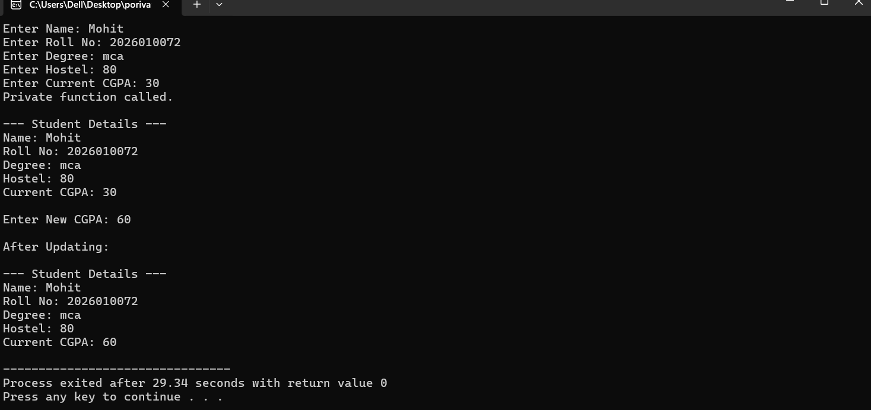
Q6. Create a code snippet that illustrates the following:
a. Calling of private member functions inside public member function
b. Access private member functions inside public member function
Ans6. A.
#include <iostream>
using namespace std;

class Student
{
private:
void privateFunction()
{
cout << "Private function called." << endl;
}

public:
void publicFunction()
{
// Calling private member function
privateFunction();
}
};

int main()
{
Student s;

// Public function can be accessed using object
s.publicFunction();

return 0;
}
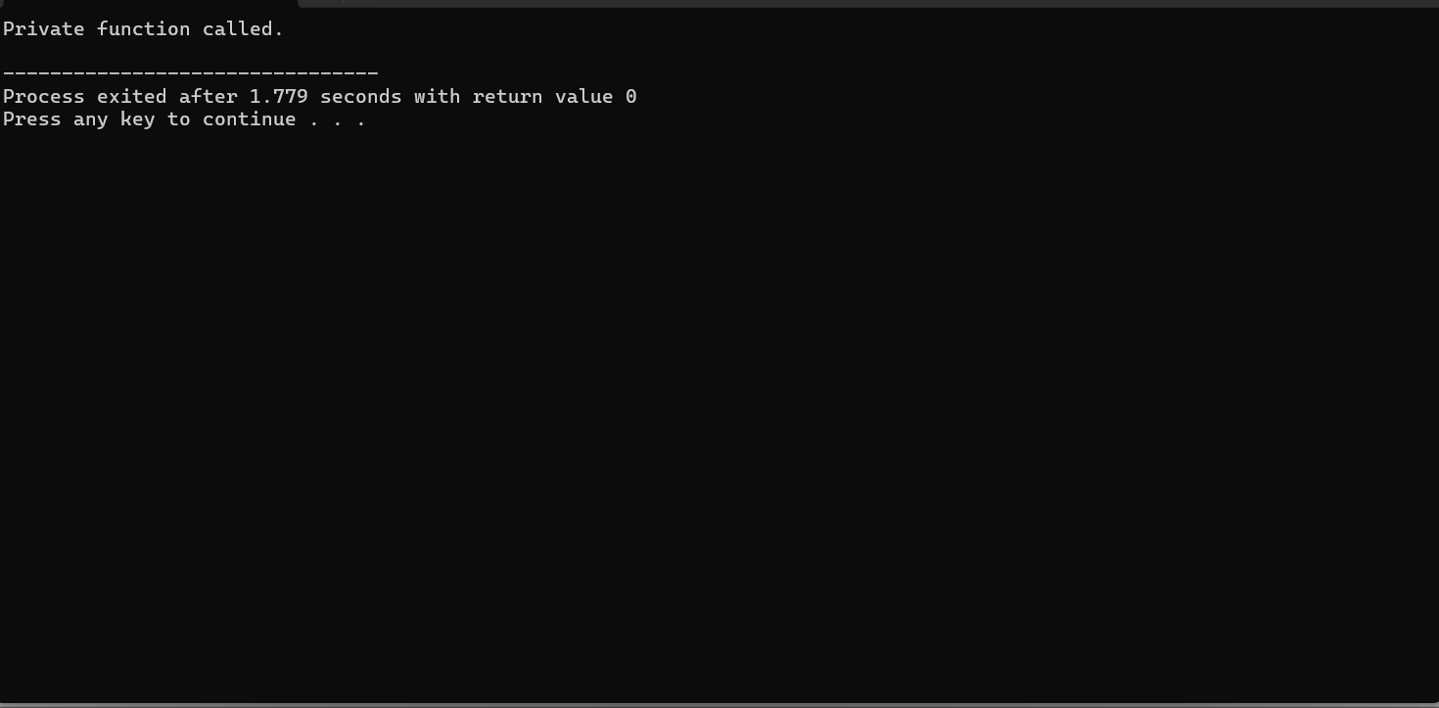
Ans 6. B.
#include <iostream>
using namespace std;

class Demo
{
private:
void privateFunction()
{
cout << "Private member function called" << endl;
}

public:
void publicFunction()
{
privateFunction(); // Accessing private function
}
};

int main()
{
Demo obj;
obj.publicFunction();

return 0;
}
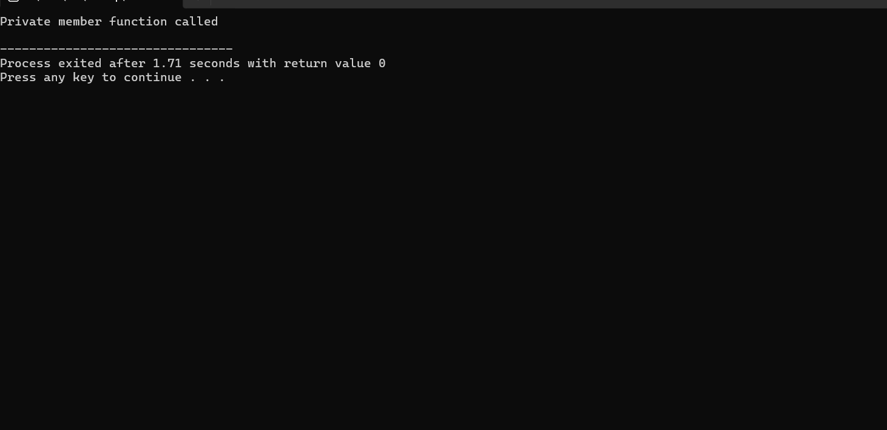

Q7. 7. Define a class named Complex with properties (real and imaginary) and methods as
per following details.
void set () to initialize object values.
void display () to display complex number.
Complex sum (Complex) or void sum (Complex) to add two complex numbers
(objects of Complex class) and return complex_number (object of Complex
class) as result.
Properties (real and imaginary) of the code should have private access modifier and
member functions should have public access modifier in C++ class?
Ans 7. #include <iostream>
using namespace std;

class Complex
{
private:
float real, imaginary;

public:
void set()
{
cout << "Enter real part: ";
cin >> real;
cout << "Enter imaginary part: ";
cin >> imaginary;
}

void display()
{
cout << real << " + " << imaginary << "i" << endl;
}

Complex sum(Complex c)
{
Complex temp;
temp.real = real + c.real;
temp.imaginary = imaginary + c.imaginary;
return temp;
}
};

int main()
{
Complex c1, c2, c3;

cout << "Enter first complex number:" << endl;
c1.set();

cout << "Enter second complex number:" << endl;
c2.set();

c3 = c1.sum(c2);

cout << "First complex number: ";
c1.display();

cout << "Second complex number: ";
c2.display();

cout << "Sum: ";
c3.display();

return 0;
}
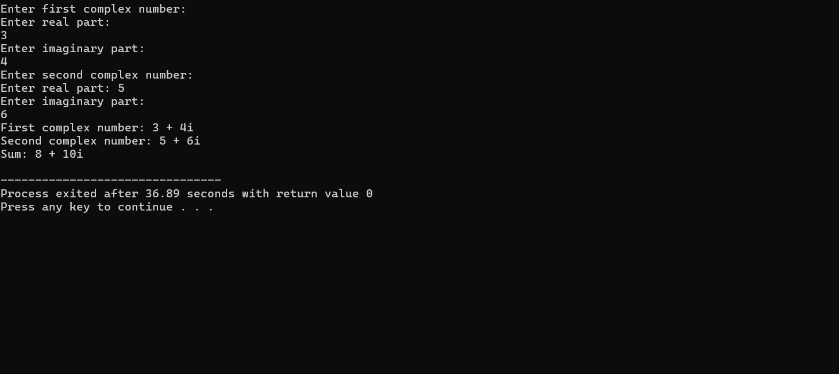

Q8: Implement namespace in a program to illustrate the use of same name variables and
functions in different sections/libraries of the code?
Ans8.
#include <iostream>
using namespace std;
namespace First
{
int x = 10;
void display()
{
cout << "First namespace: x = " << x << endl;
}
}
namespace Second
{
int x = 20;
void display()
{
cout << "Second namespace: x = " << x << endl;
}
}

int main()
{
First::display();
Second::display();

cout << "First x = " << First::x << endl;
cout << "Second x = " << Second::x << endl;

return 0;
}
